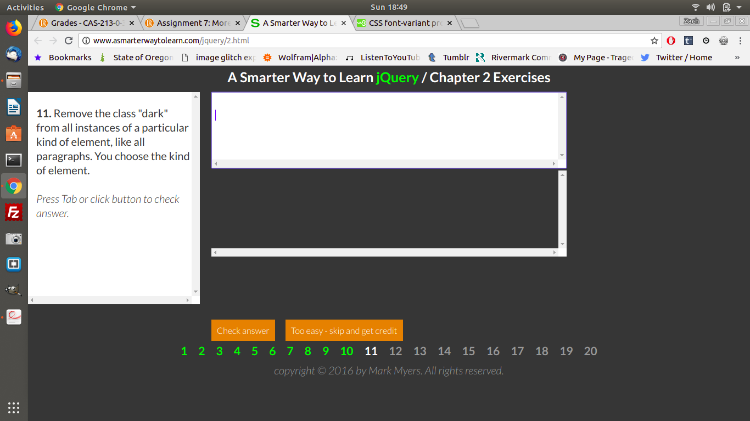
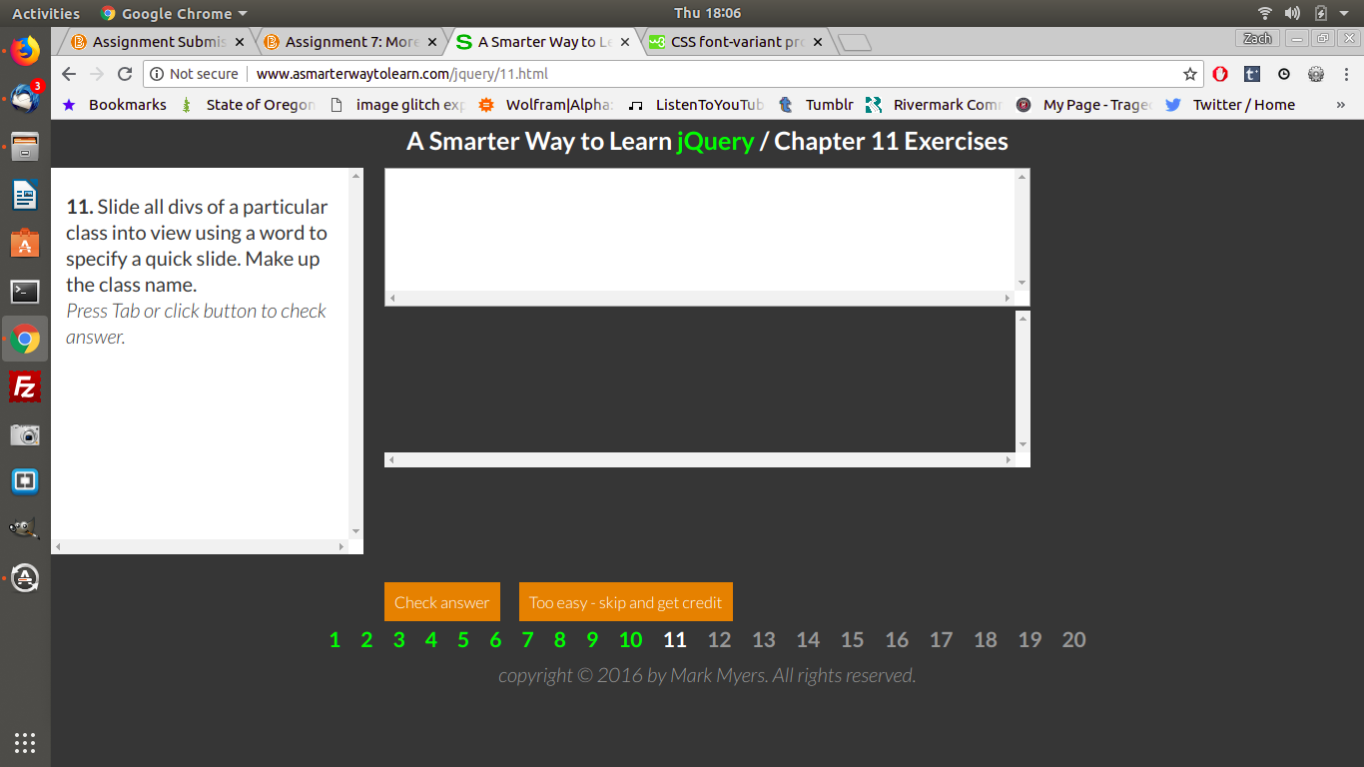

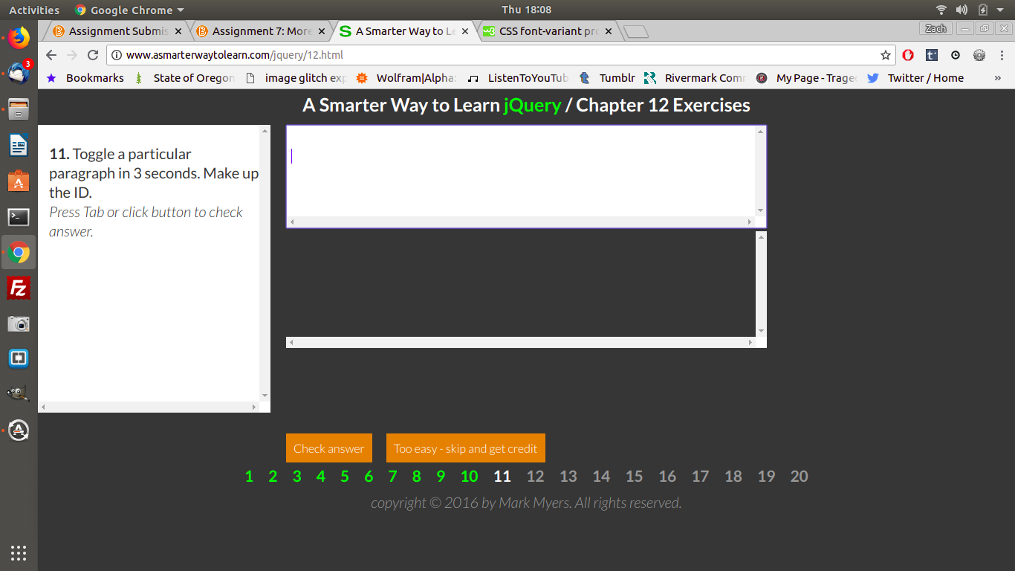

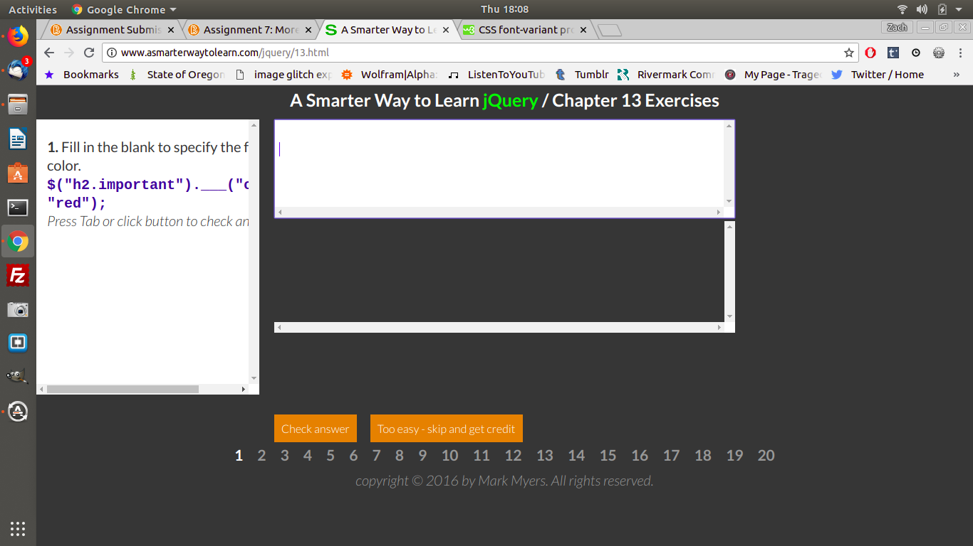

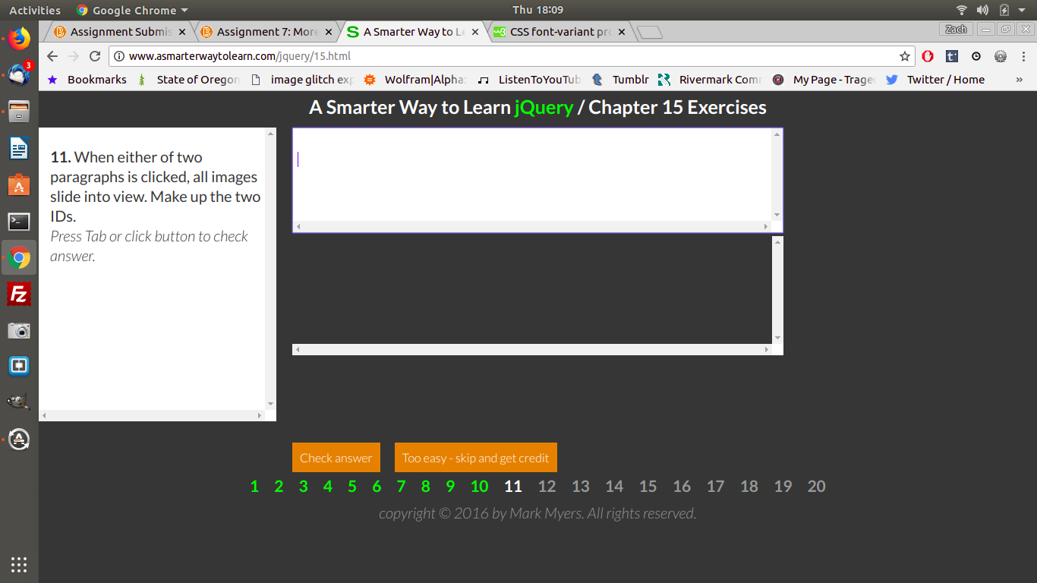

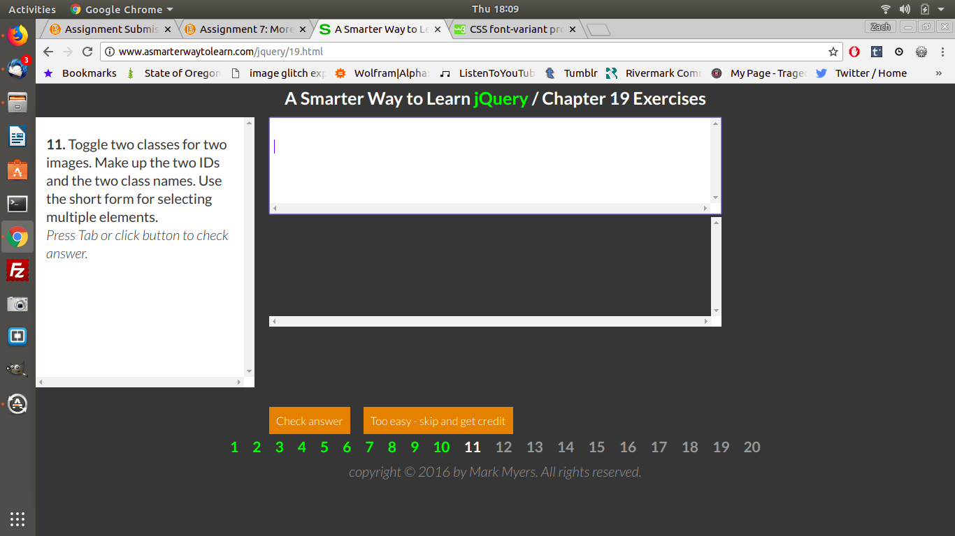

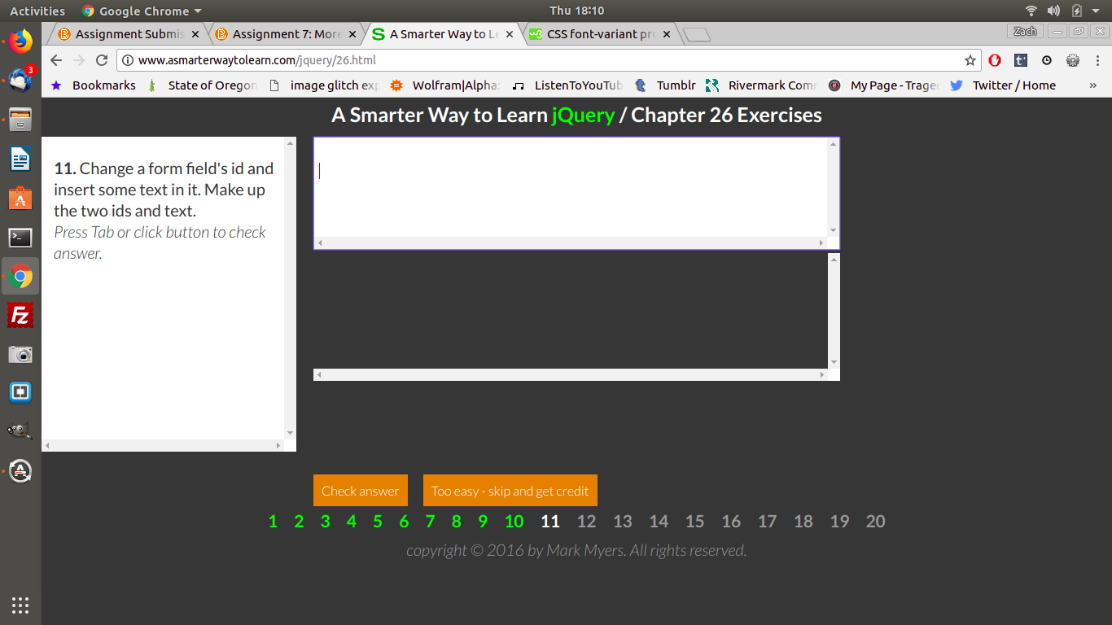

Pseudocode to calculate the area of a rectangle:
1. Create 3 text boxes, one to input the width (a) one to input the length (b) and one to output the answer (c).
2. Create variables to hold the width (recWidth), the length (recLength), and the result (ansArea).
3. Get the width from text box (a), and assign it to the variable recWidth.
4. Get the length from text box (b) and assign it to the variable recLength.
5. Calculate recWidth * recLength and assign the result to the variable ansArea.
6.Assign the answer to text box (c).

